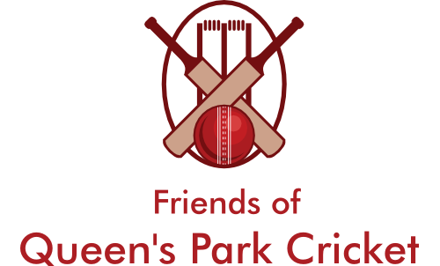
Friends of Queen’s Park Cricket
Registered Charity No. 1177204

Trustees Required
The Friends of Queen’s Park Cricket was formed to celebrate the past, to maintain the current and to ensure the future of cricket at this historic cricket ground. In doing this it will try to increase participation in the number of people enjoying cricket at all levels. This will involve people playing, watching, increasing their skills and learning about cricket and the role the Queen’s Park has had over a number of years.
We are seeking to appoint new trustees to assist us in achieving our objectives.
The duties of a trustee are broadly:
- to ensure that the charity complies with its governing document, charity law, company law, and any other relevant legislation or regulations;
- to ensure that the charity pursues its charitable objects as defined in its governing document;
- to ensure that the charity applies its resources exclusively in furtherance of its objects,
- to contribute actively to the board of trustees’ role of giving firm strategic direction to the charity
- to safeguard the good name and values of the charity;
- to protect and manage the property of the charity and to ensure the proper investment of the charity’s funds;
Person Specification
- A commitment to the values and objectives of the Friends of Queen’s Park Cricket
- An ability to work effectively as a member of a team
- An ability to communicate effectively
- An ability to make sound, independent judgements
- An ability to think creatively
- An understanding and acceptance of the legal duties, responsibilities and liabilities of trusteeship
Time Commitment
- There are four/five trustee meetings each year. These are held in the evening and usually last two hours.
- Undertaking tasks to promote the success of the organisation ( 4hrs. per month)
- Attendance at some of the events organised by FQPC and at the Chesterfield Festival of Cricket
Further Information
Please E Mail mail@fqpc.org.uk or phone 07712 526354

